Day 2 Coding Assessment

Code:

index.html code:
<!DOCTYPE html>
<html lang="en">
<head>
<meta charset="UTF-8">
<meta name="viewport" content="width=device-width, initial-scale=1.0">
<title>Student Login | Spring Flowers School</title>
<link rel="stylesheet" href="style.css">
</head>
<body>

<header>
<img src="School Image.jpg" alt="School Logo" class="logo">
<h1>Spring Flowers School</h1>
</header>

<main>
<div class="login-container">
<h2>Student Login</h2>

<div class="input-group">
<label for="username">Username:</label>
<input type="text" id="username" placeholder="Enter Username">
</div>

<div class="input-group">
<label for="password">Password:</label>
<input type="password" id="password" placeholder="Enter Password">
</div>

<button type="button" onclick="login()">Login</button>

<p>Don’t have an account? <a href="#" onclick="toggleRegister()">Register</a></p>

<div id="register-section" class="hidden">
<h3>Register</h3>

<div class="input-group">
<label for="newUsername">Username:</label>
<input type="text" id="newUsername" placeholder="Enter New Username">
</div>

<div class="input-group">
<label for="newPassword">Password:</label>
<input type="password" id="newPassword" placeholder="Enter New Password">
</div>

<button type="button" onclick="register()">Register</button>
</div>
</div>
</main>

<footer>
<p>&copy; 2025 Spring Flowers School</p>
</footer>

<script src="script.js"></script>
</body>
</html>

profile.html code:
<!DOCTYPE html>
<html lang="en">
<head>
<meta charset="UTF-8">
<meta name="viewport" content="width=device-width, initial-scale=1.0">
<title>Welcome | Spring Flowers School</title>
<link rel="stylesheet" href="style.css">
</head>
<body>

<header>
<img src="School Image.jpg" alt="School Logo" class="logo">
<h1>Welcome to Spring Flowers School</h1>
</header>

<nav>
<ul>
<li><a href="profile.html">Home</a></li>
<li><a href="monthly.html">Monthly Activities</a></li>
<li><a href="#" onclick="logout()">Logout</a></li>
</ul>
</nav>

<main>
<h2 id="welcomeMessage"></h2>
<p>Welcome to your online Student Management portal.</p>
<p>Click on <strong>Monthly Activities</strong> to view your subject-wise tasks.</p>
</main>

<footer>
<p>&copy; 2025 Spring Flowers School</p>
</footer>

<script src="script.js"></script>
</body>
</html>

monthly.html code:
<!DOCTYPE html>
<html lang="en">
<head>
<meta charset="UTF-8">
<meta name="viewport" content="width=device-width, initial-scale=1.0">
<title>Monthly Activities | Spring Flowers School</title>
<link rel="stylesheet" href="style.css">
</head>
<body>

<header>
<img src="School Image.jpg" alt="School Logo" class="logo">
<h1>Monthly Activities</h1>
</header>

<nav>
<ul>
<li><a href="profile.html">Home</a></li>
<li><a href="monthly.html">Monthly Activities</a></li>
<li><a href="#" onclick="logout()">Logout</a></li>
</ul>
</nav>

<main>
<h2>Select Subject</h2>

<div class="input-group">
<label for="subjectDropdown">Subject:</label>
<select id="subjectDropdown" onchange="showActivities()">
<option value="">--Select Subject--</option>
<option value="Maths">Maths</option>
<option value="Science">Science</option>
<option value="English">English</option>
<option value="History">History</option>
</select>
</div>

<ul id="activityList"></ul>
</main>

<footer>
<p>&copy; 2025 Spring Flowers School</p>
</footer>

<script src="script.js"></script>
</body>
</html>

style.css code:
/* Global Styles */
body {
font-family: Arial, sans-serif;
margin: 0;
padding: 0;
background-color: #f1eeee;
}

/* Header */
header {
background-color: #161e20;
color: white;
text-align: center;
padding: 15px 0;
}

header .logo {
width: 80px;
height: 80px;
border-radius: 50%;
display: block;
margin: 0 auto 10px;
}

/* Navigation */
nav ul {
list-style: none;
padding: 0;
margin: 0;
text-align: center;
background-color: #423c54;
}

nav li {
display: inline-block;
}

nav a {
color: white;
text-decoration: none;
padding: 12px 20px;
display: inline-block;
}

nav a:hover {
background-color: #a9a296;
}

/* Main Content */
main {
display: flex;
flex-direction: column;
align-items: center;
justify-content: flex-start;
padding: 20px;
min-height: 60vh;
text-align: center;
}

/* Login/Register Container */
.login-container {
background-color: rgb(249, 239, 239);
max-width: 400px;
width: 90%;
margin: 40px 0;
padding: 30px;
border-radius: 10px;
box-shadow: 0px 0px 12px #3b0e0e;
display: flex;
flex-direction: column;
align-items: center;
}

/* Input Group */
.input-group {
display: flex;
flex-direction: column;
align-items: center;
width: 100%;
margin-bottom: 15px;
}

.input-group label {
width: 90%;
text-align: left;
font-weight: bold;
margin-bottom: 5px;
}

/* Input & Dropdown */
.input-group input,
.input-group select {
width: 100%;
max-width: 400px;
padding: 15px;
font-size: 1.1rem;
border-radius: 8px;
border: 1px solid #6a0505;
box-sizing: border-box;
margin-bottom: 15px;
text-align: left;
}

/* Buttons */
button {
width: 100%;
max-width: 400px;
padding: 15px;
font-size: 1.1rem;
background-color: #94ca62;
color: rgb(248, 243, 243);
border: none;
border-radius: 8px;
cursor: pointer;
margin-top: 10px;
transition: background-color 0.3s;
}

button:hover {
background-color: #863ec8;
}

/* Activity List */
#activityList {
list-style: none;
padding-left: 0;
width: 90%;
max-width: 500px;
margin-top: 20px;
}

#activityList li {
background-color: rgb(255, 255, 255);
padding: 15px;
margin-bottom: 10px;
border-radius: 8px;
border: 1px solid #2c2424;
text-align: left;
font-size: 1rem;
word-wrap: break-word;
}

/* Welcome Message */
#welcomeMessage {
font-size: 1.8rem;
margin-bottom: 20px;
}

/* Hidden Class */
.hidden {
display: none;
}

/* Footer */
footer {
text-align: center;
padding: 15px 0;
background-color: #253032;
color: white;
margin-top: 20px;
}

/* Responsive Styles */
@media screen and (max-width: 768px) {
header .logo {
width: 60px;
height: 60px;
}

#activityList li {
font-size: 0.95rem;
padding: 12px;
}

.input-group input,
.input-group select,
button {
font-size: 1rem;
padding: 12px;
}

nav a {
padding: 10px 15px;
}

h1 {
font-size: 1.5rem;
}

h2 {
font-size: 1.3rem;
}
}

@media screen and (max-width: 480px) {
header .logo {
width: 50px;
height: 50px;
}

.login-container {
padding: 20px;
}

.input-group input,
.input-group select,
button {
font-size: 0.95rem;
padding: 10px;
}

h1 {
font-size: 1.2rem;
}

h2 {
font-size: 1.1rem;
}

#activityList li {
font-size: 0.9rem;
padding: 10px;
}
}

script.js code:
// User Storage
let users = JSON.parse(localStorage.getItem("users")) || [];

// Register
function register() {
const newUsername = document.getElementById("newUsername").value.trim();
const newPassword = document.getElementById("newPassword").value.trim();

if (!newUsername || !newPassword) {
alert("Please fill all fields!");
return;
}

if (users.find(u => u.username === newUsername)) {
alert("Username already exists!");
return;
}

users.push({ username: newUsername, password: newPassword });
localStorage.setItem("users", JSON.stringify(users));
alert("Registration successful! You can now login.");

document.getElementById("newUsername").value = "";
document.getElementById("newPassword").value = "";
toggleRegister();
}

// Toggle Register Form
function toggleRegister() {
const reg = document.getElementById("register-section");
reg.classList.toggle("hidden");
}

// Login
function login() {
const username = document.getElementById("username").value.trim();
const password = document.getElementById("password").value.trim();

const user = users.find(u => u.username === username && u.password === password);
if (!user) {
alert("Invalid credentials!");
return;
}

localStorage.setItem("loggedInUser", username);
window.location.href = "profile.html";
}

// Logout
function logout() {
localStorage.removeItem("loggedInUser");
window.location.href = "index.html";
}

// Protect Pages
const user = localStorage.getItem("loggedInUser");
if ((document.getElementById("welcomeMessage") || document.getElementById("subjectDropdown")) && !user) {
alert("Please login first!");
window.location.href = "index.html";
}

// Welcome Message
if (document.getElementById("welcomeMessage") && user) {
document.getElementById("welcomeMessage").innerText = `Welcome, ${user}!`;
}

// Activities
const activities = [
{ id: 1, activity: "Create project file (tables 12-19)", subject: "Maths" },
{ id: 2, activity: "Perform science experiment on chemical reactions", subject: "Science" },
{ id: 3, activity: "Write an essay on global warming", subject: "English" },
{ id: 4, activity: "Prepare timeline of Indian independence", subject: "History" }
];

// Show Activities
function showActivities() {
const subject = document.getElementById("subjectDropdown").value;
const list = document.getElementById("activityList");
list.innerHTML = "";

if (!subject) return;

const filtered = activities.filter(a => a.subject === subject);
if (!filtered.length) {
list.innerHTML = "<li>No activities found.</li>";
return;
}

filtered.forEach(a => {
const li = document.createElement("li");
li.textContent = a.activity;
list.appendChild(li);
});
}

Reference Image:


Screenshots:

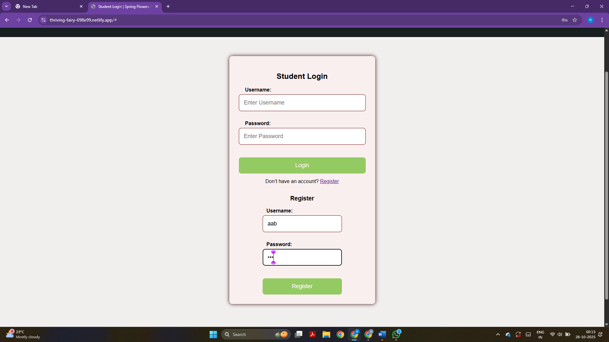

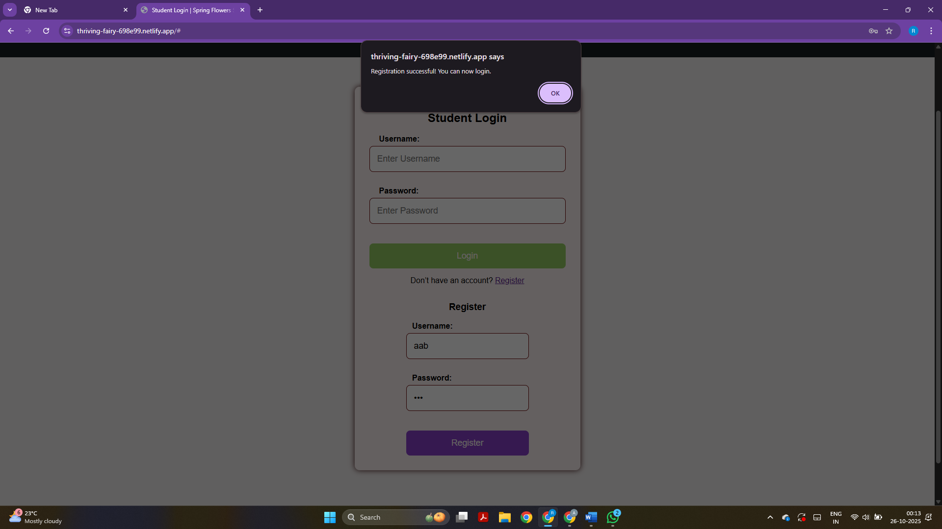

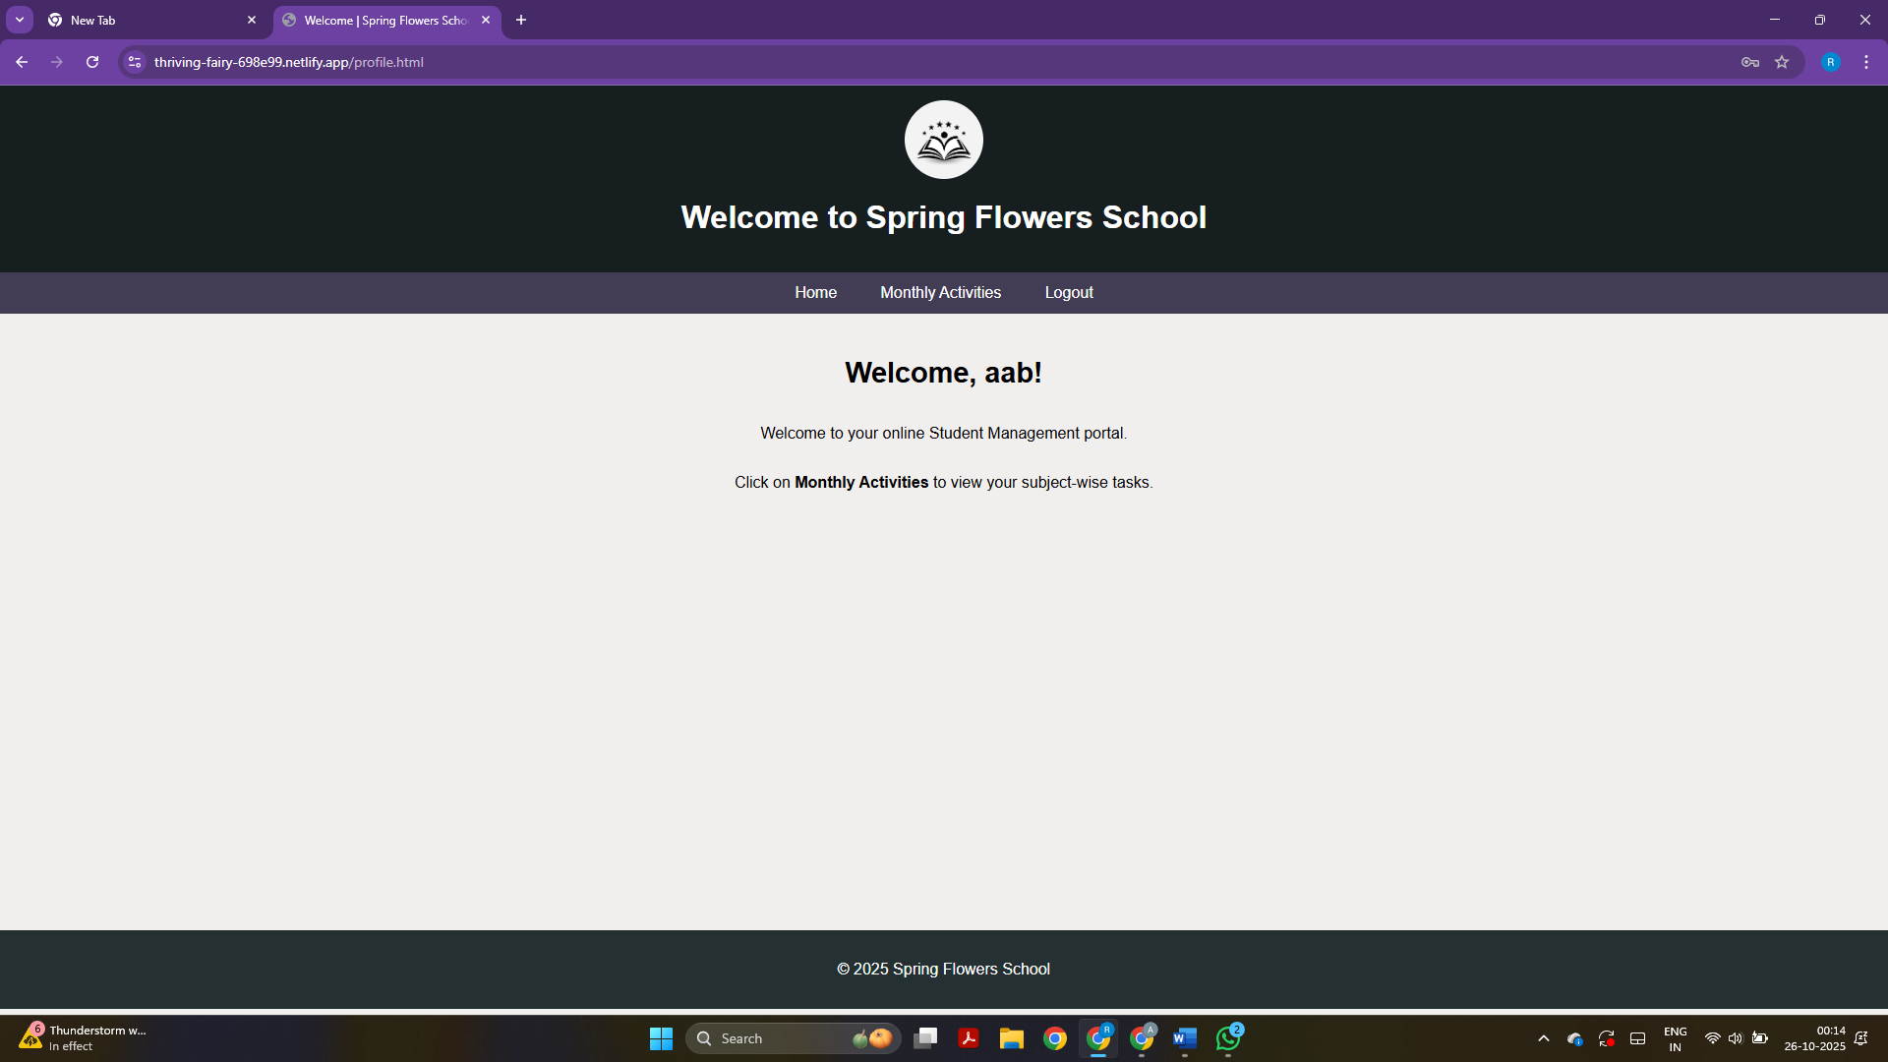

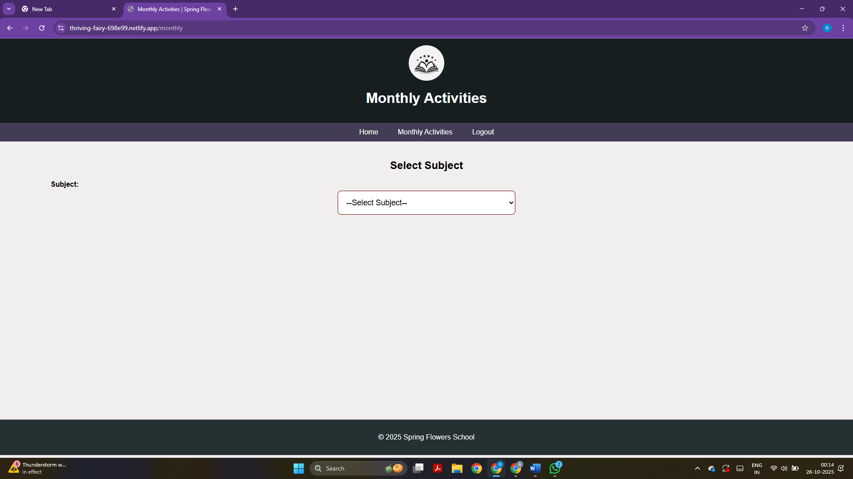

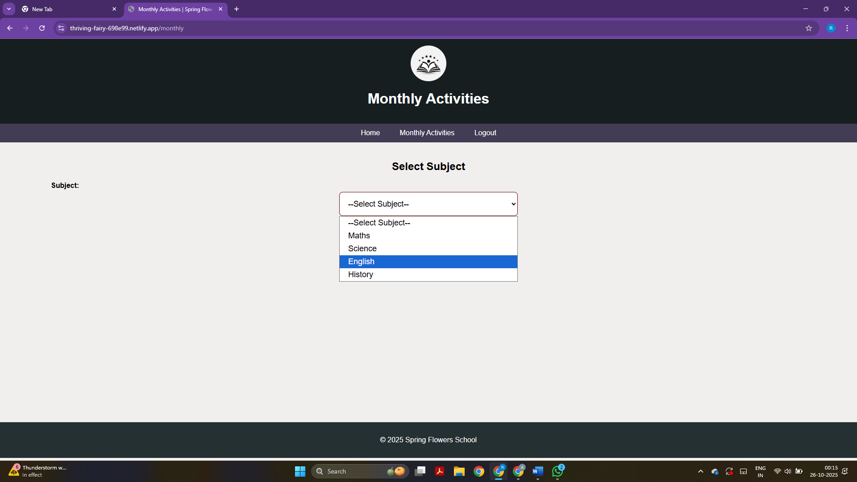

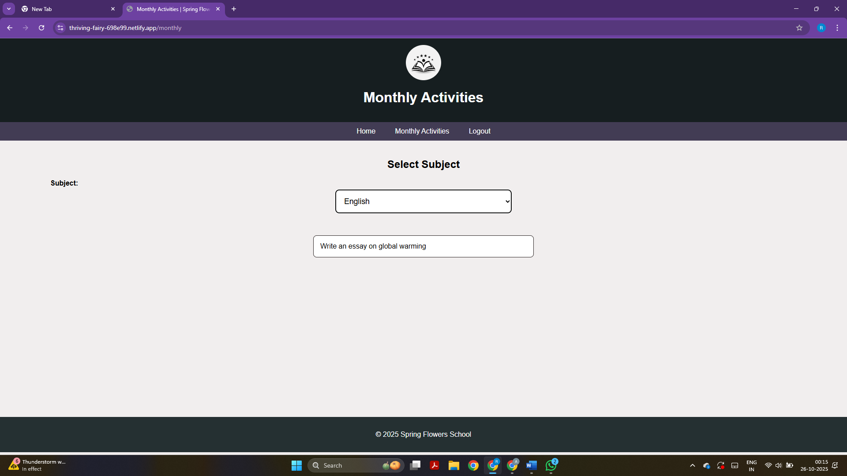

Link: https://thriving-fairy-698e99.netlify.app/

